**EE324 Control Systems Lab**

Problem sheet 7

Tarun Sai Goddu | 190070024

**Question 1**

Given

G(s) = 1 /s(s^2+4s+8)

* 1. Part A

Scilab Code:

s = poly(0,'s');

G = 1/(s*(s^2 + 4*s + 8));

sys = syslin('c', G);

K = 0.01:0.01:100;

phm = zeros(length(K), 1);

gm = zeros(length(K), 1);

frp = zeros(length(K), 1);

frg = zeros(length(K), 1);

i = 1;

for k = K

sys1 = (k*sys);

[phm(i),frp(i)] = p_margin(sys1);

[gm(i), frg(i)] = g_margin(sys1);

i = i + 1;

end

scf();

plot(K,phm,'b');

plot(K,gm,'r');

K = 32;

sys = (K*sys);

char = 1 + sys;

poles = roots(char.num);

disp(poles);

show_margins(sys);

By the use of scilab defined functions, we obtain the following plot for the open loop transfer function G(s):

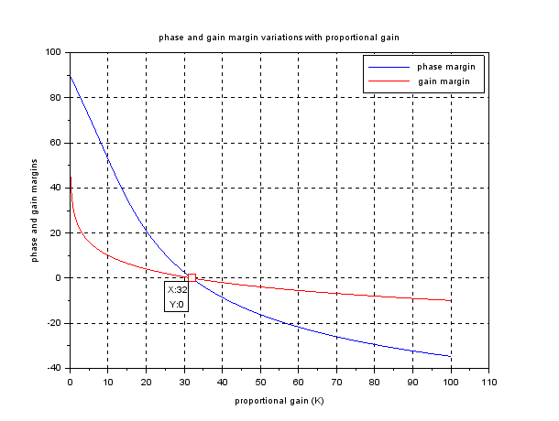

Figure 1: Phase Margin and Gain Margin vs Proportional Gain (K)

As is visible from the above plot, the value of K (gain) for which the gain and phase margin are both equal to zero is 32.

1. Part (b)

No, as shown in Figure 1, there is therefore no gain (K), with a gain of 0, but a margin of the phase is not null. The two only cross the x-axis once and again.

1. Part (c)

Poles of closed loop system when K = 32 are -4, ±2.8284i

Since we have poles of the closed loop system on the imaginary axis, the system is marginally stable. The bode plot for the above system is shown below:

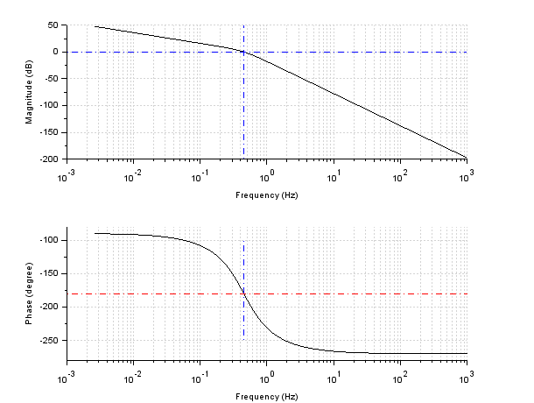

Figure 2: Bode plot of system for K = 32

**Question 2**

We are given a closed loop system with negative unity feedback with open loop transfer function as follows

Gopen(s) = 1/(s+2)(s+1)

For obtaining the desired specifications, a lag compensator is used with a transfer function:

C(s) = K(s+z)/(s+p) with z/p = 20

2a

Constant gain K to achieve 10% OS in the closed-loop. We obtain the locus of 10% OS as follows:

Therefore, PI controller to be used is:

It is a straight line with angle of tan^-1((1-p^2)^1/2/p)

((1-p^2)^1/2/p = Pi/ln(10)

Therefore, we obtain the open loop contant gain K = 4.44

2b

The steady state error of the above system upon step input comes out be = 1-0.689 = 0.311 The unit step response is shown below:

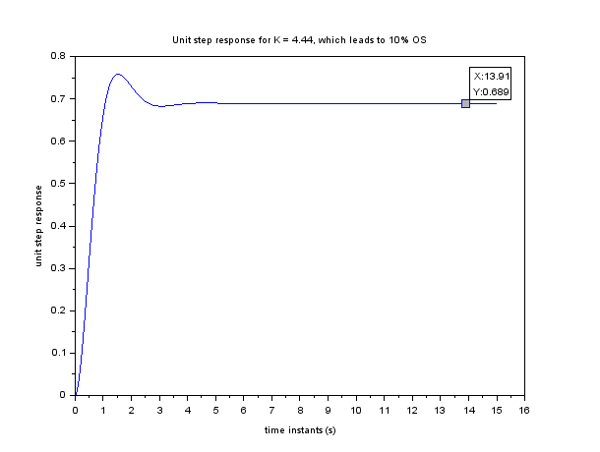

Step response for 2b without Lag compensator

After placing the lag compensator, we obtain the following step response, which gives steady state error = 1- 0.978 = 0.022

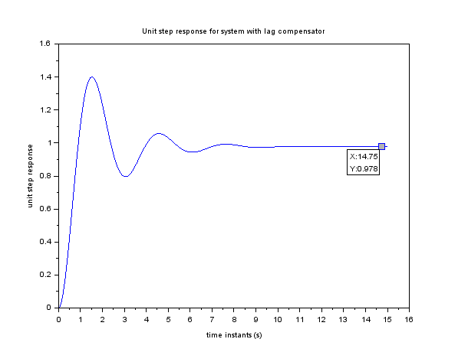

Step response for 2b without Lag compensator

Lag compensator used had the following trransfer function:

C(s) = 4.44(s + 2)/ (s + 0.1)

s=poly(0,'s');

z = 0.01;

G = 1/((s+1)*(s+2));

sysG = syslin('c',G);

pi = 3.1415;

*//from 10 % OS we get k = 4.44*

k = 4.44;

t=0:0.01:15;

sysT = syslin('c',k*G/(1+k*G));

step_r = csim('step',t,sysT);

fig=scf();

2c

We observe the following graphic when we change the polar-zero position while preserving the ratio. When z rises from 0.1 to 4.1, it will reduce and increase the damping ratio. And the lag compensator takes greater time to come into action as z values increases. All the systems are stable though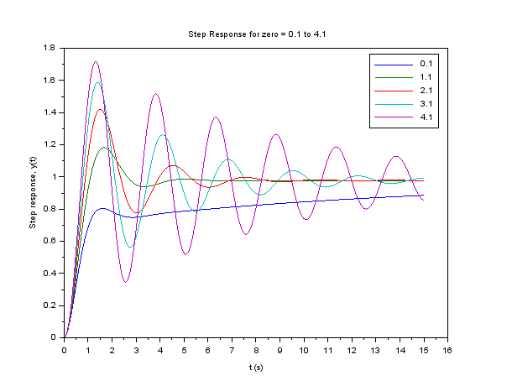

Step response for 0.1 ⩽ z ⩽ 4.1:

When zero is increased from 1 to 51 we observe that system becomes unstable as z increases beyond 5.1. When z is increased from 1 to 51, the %OS increase and system becomes unstable after z crosses 5.1. And the lag compensator takes lesser time to come into action as z values increases. The plot is shown below:

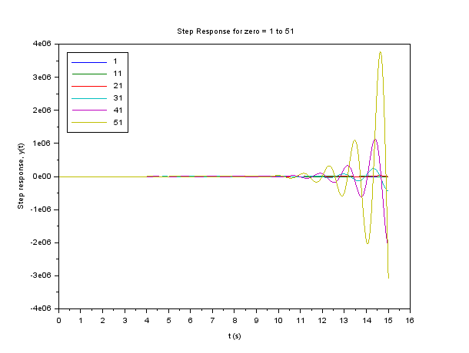

Step response for 1 ⩽ z ⩽ 51

We thus observe that the system becomes unstable or increases % OS (in case of stable systems), as the z value increases, and when we compromise, the compensator lags provide a better response time.

Scilab code:

k = 4.44;

t=0:0.01:15;

fig=scf();

z = 0.1 : 1 : 4.1;

y = zeros(length(t),length(z));

i=1;

for z1 = z

p = z1/20;

C = (s+z1)/(s+p);

H = C*G;

sysT = syslin('c',k*H/(1+k*H));

y(:,i) = csim('step', t, sysT);

i=i+1;

end

plot(t, y);

xlabel("t (s)")

ylabel("Step response, y(t)")

title("Step Response for zero = 0.1 to 4.1");

f = gcf();

**Question 3**

Given transfer function:

G(s) = 1 /s^2+ 3s+2

3a

Need to design a lead compensator for G(s) to obtain half 2% settling time of that in Q2-a. For 2-a, the settiling time was 2.33 s. Therefore required settling time = halving the settling time we can double the magnitude of Re(pole) as: For 10% OS we obtain damping ratio (𝜌) as:

𝜌 = (ln(10)/ln(10)+pi^2)^1/2 = 0.43

2% settling time*Re(pole) = -ln(0.02(1- 𝜌^2)^1/2

Re(pole) = -3.448

Therefore we see that Re(pole) reqired is -3.448 (as assumed stable system, while applying the formula). Intersection with required %OS = 10 locus

Therefore we get 2 pole values of the desired system as: -3.448 ± 4.705j

Now upon changing the varying the z and p values in the lead compensator transfer function shown below:

C(s) = K(s + z/ s + p)

We obtain p = 9.318, z = 4 and K = 41.47 for having pole values as -3.448 ± 4.705j. The plot is shown below:

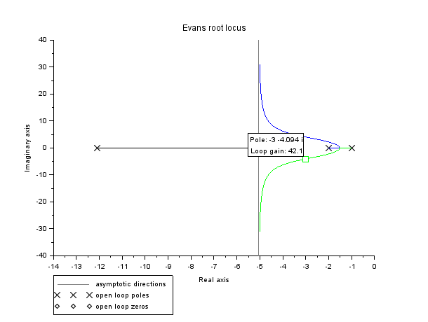

Figure : RL plot of the obtained system

Therefore, required lead compensator is as follows:

C(s) = 41.47(s+4/s+9.318)

Scilab code:

s=poly(0,'s');

z = 0.01;

G = 1/((s+1)*(s+2));

sysG = syslin('c',G);

pi = 3.1415;

theta=atan((pi/log(10)));

a=[0:0.01:10];

fig=scf();

evans(sysG, 2000);

x=-cos(theta)*a;

y=sin(theta)*a;

plot(x, y, 'k--');

z = 4;

p = 9.318;

C = (s+z)/(s+p);

H = C*G;

sysH = syslin('c',H);

fig=scf();

evans(sysH,1000);

3b

Same specifications as above with a PD controller C(s) specified below:

C(s) = K(s+z)

Again 2 pole values of the desired system as: -3.448 ± 4.705j , hence upon varying values of z and K for having the above 2 points on RL plot, we obtain z = 8.223 and K = 3.897.

Therefore, required PD controller has following transfer function:

C(s) = 3.897(s + 8.223)

The plot with required pole labelled is shown below:

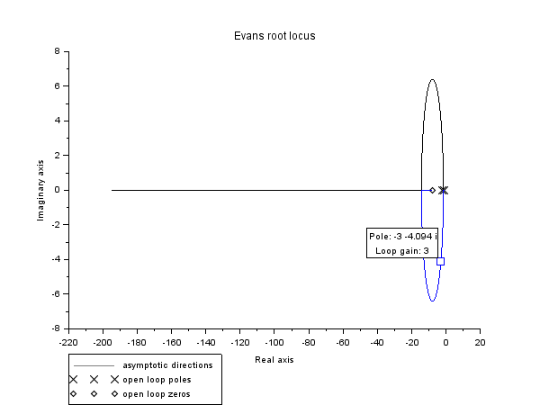

Root locus for Obtained system

Scilab code:

s=poly(0,'s');

z = 0.01;

G = 1/((s+1)*(s+2));

sysG = syslin('c',G);

pi = 3.1415;

theta=atan((pi/log(10)));

a=[0:0.01:10];

fig=scf();

evans(sysG, 2000);

x=-cos(theta)*a;

y=sin(theta)*a;

plot(x, y, 'k--');

z = 8.223;

C = (s+z);

H = C*G;

sys = syslin('c',H);

evans(sys, 200);